I. INTRODUCTION

Efforts to utilize and increase the natural resources (soil) properly require accurate data (information) to be used by farmers in determining what types of plants are suitable (appropriate) with the condition of the land to be planted. Mismatch of plant species to be planted with surrounding soil conditions will lead to undesirable conditions of farmers themselves such as crop failures and other bad things. This problem is what inspired the writer to design and build an intelligent system (application) that can be a solution for farmers in making decisions about what type of plant suitable for planting in his land.

II. RELATED WORK

The research that the authors do is also influenced by a number of other research journals that have been done by previous researchers. The following are related journals: [1] Decision support system for the determination of food crops using the web-based AHAP (Analytic Hierarchy Process) method. [2] Decision support system for potential land assets of West Java province. [3] Geographic Information System based on geothermal mapping of geothermal potential in Indonesia using Google Maps. [4] Design of Geographic Information System of Agriculture and Plantation in Muara Enim district based on the web. [5] Decision support systems for selection of planting of improved rice varieties using the ISP and Topsis methods. [6] Establishment of the geographic information system of the land suitability of sugarcane plantation based on the web in Merauke district. [7] Web-based Geographic Information System for mapping agricultural commodities in the "XYZ" district. [8] AHP-based decision support system (Analytical Hierarchy Process) for determining land suitability (case study: Semarang district). [9] Design of the geographic information system of the land suitability of corn crop based on the web. [10] Design of the geographic information system of the land suitability of Gogo-based rice plantation web.

Journal of research authors with previous research journals mentioned above have similarities and differences. The similarity is decision making using the AHP method and used for agricultural land use. While the difference is the product of web-based and mobile writer research, using Google Map API, Open Weather Map API.

III. DESIGN OVERVIEW

The system design in this research using Unified Process method (UP) one of the method in Agile Development System. While the output of decision-making produced by its own application using AHP method. The data output (information) generated by this intelligent application must be accurate. In order to get it a number of research objects, the author took such as Soil pH, Temperature, Humidity, Soil Altitude, Soil Depth, and Soil Thickness.

Analysis of decision making as a result of the application using AHP method. This method grouping, sorting, collecting, marking and categorizing issues to be solved.

* Uses case Diagram Sistem

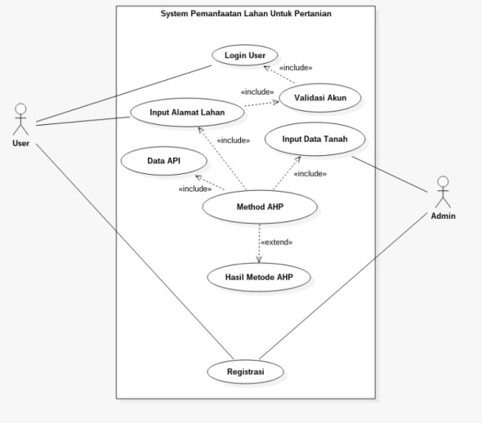

* Activity Diagram (Admin)

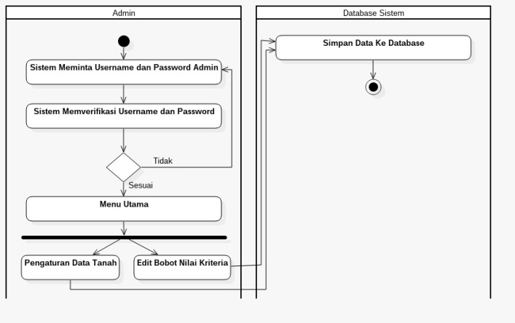

* Activity Diagram (User)

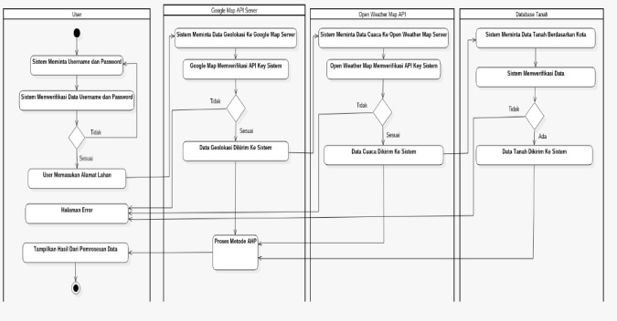

* Squence Diagram

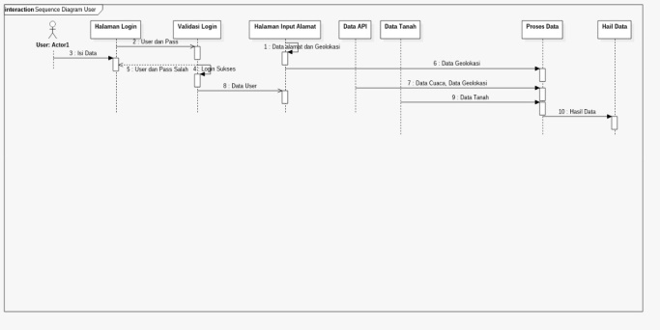

* Class Diagram

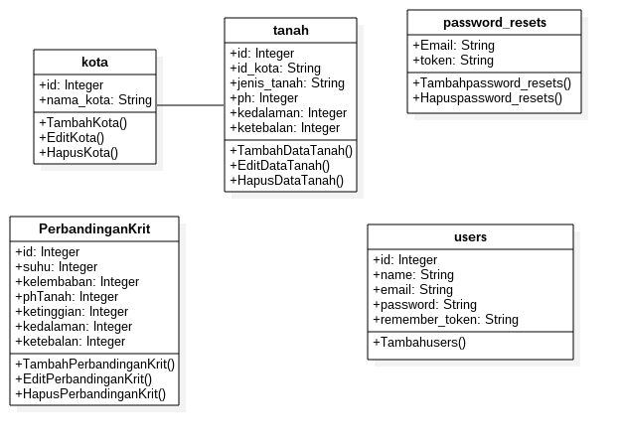

This stage is the stage to implement the system design using Laravel framework while the Database using MySQL Database Server.

The next stage is the Testing and Evaluation stage. This stage aims to determine the weaknesses of the system made and fix it in order to be accepted user system (application). The method used in testing the system (application) is Blackbox Testing. At this stage, the application requires an internet connection or Wi-Fi network.

IV. RESULT AND DISCUSSION

The making of this system takes data and knowledge from Human Expert and various types of books and documents of land survey reports obtained from government agencies of Badan Pusat Statistik (BPS). Here are some application testing screenshots that have been done.

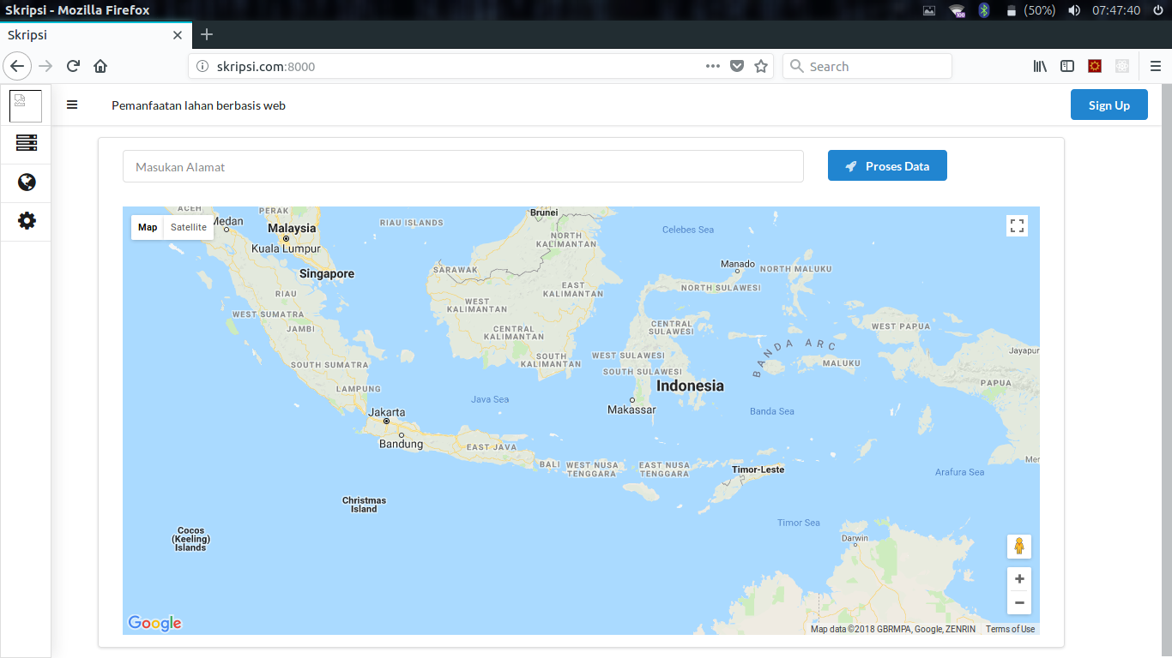Fig. 1 Landing Page User

The picture above is the user view to fill the form of address of the land that will be checked by the system.

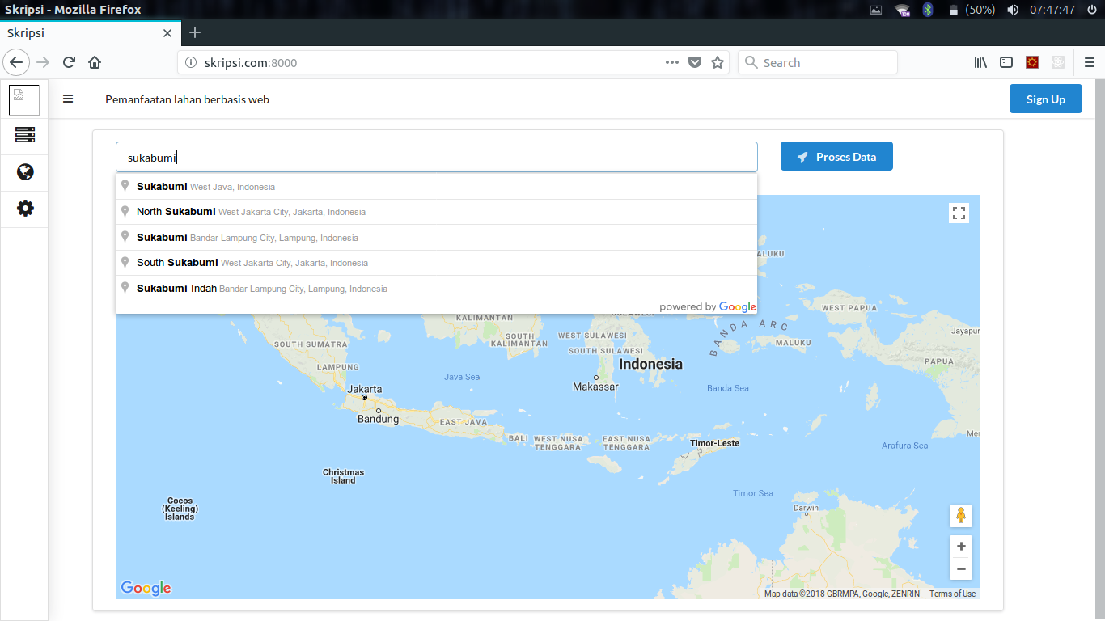Fig. 2 Auto Complete Address

When the User fills in the form address then the system will automatically find the appropriate address with input user input into the system.

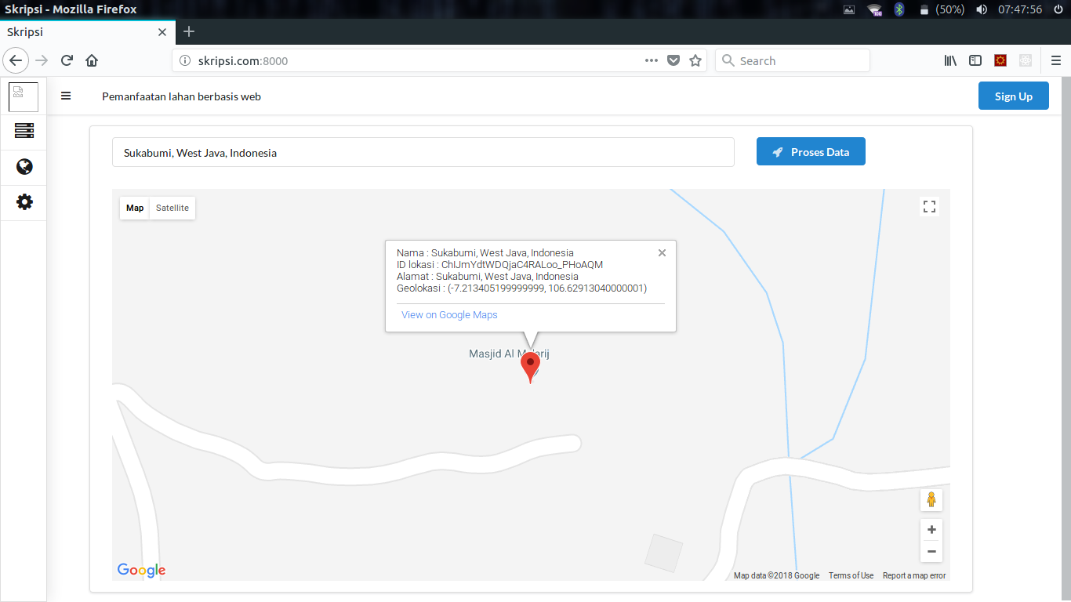

Fig.3 Map Location.

When the user has filled the address form and hit enter then the tomato map on the page will change according to the address that the user input in the input address field.

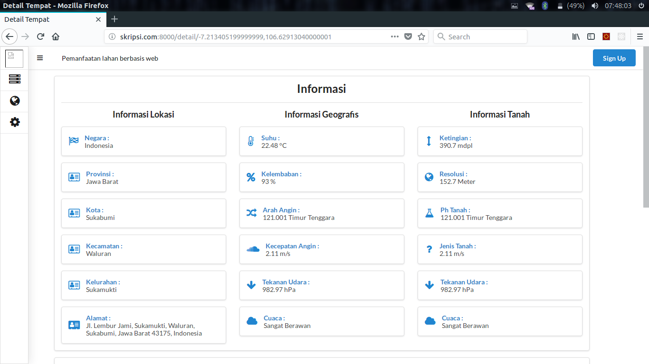

Fig.4 Data Of Land.

After the User clicks the data process then the system will automatically search the data from the server then process it and the results will be displayed on the user page.

V. CONCLUSION

The system can display the appropriate plant species under tested soil conditions, such as what plants are suitable or closely approximated to allow for planting on the land. In addition, the system will show and store the coordinates of each agricultural land as a mapping that can be used to determine the position of agricultural land and crops suitable for agriculture.

REFERENCE

[1] Ladjamudin, Al-Bahra bin. 2005. *Analisis dan Desain Sistem Informasi.*Yogyakarta. Penerbit Geraha Ilmu.

[3] *IEEE Standards Collection* : Rekayasa Perangkat Lunak, *IEEE Standard 610.12-1990, IEEE, 1993*.

[4] Lawrance, Jeremy., 2015 Mengenal *Framework Laravel*.[Online] Tersedia di : http://laravel.id/mengenal-framework-laravel/ [Diakses 06 januari 2018]

[5] *The Apache Software Foundation 1997-2018* [Online] Tersedia di : http://httpd.apache.org/ABOUT_APACHE.html/. [Diakses 05 januari 2018]

[6] Satvika Iswari ,Ni Made. 2015. Review Perangkat Lunak SatrUML Berdasarkan Faktor Kualitas *McCall ULTIMATICS, Vol*. VII, No. 1 Juni 2015, *ISSN 2085-4552*

[7] Sismoro, Heri. 2013.Rancang Bangun Sistem *Regulations* *Legislation* *Library* di Seketariat DPRD Kabupaten Jombang Memnggunakan *Embarcadero Delphi XE3*DASI Vol. 14 No. 04 Desember 2013, *ISSN: 1411-3201.*

[8] Peraturan Menteri Pertanian Nomor 79 Tentang Pedoman Kesesuaian Lahan Pada Komoditas Tanaman Pangan.OT.140/8/2013.

[9] Hakim, Lukmanul. 2009. *From Zero To A Pro Membuat Aplikasi Web Dengan PHP + Database MySQL.* Yogyakarta. Penerbit Andi.

[10] Erika, Susilo. 2011. Sistem Pendukung /keputusan Perijinan Dan Penempatan Kolam Jaring Terapung Menggunakan Metode AHP Studi Kasus PT PJB cirata. Badan Pengelolaan Waduk Cirata UNIKOM [Online].[Diakses 27 Desember 2017].